Dynamic Target Files

Use case: To dynamically create multiple target files, one for each job type of the employees.

Source: Employee table from Oracle DB

Target: Dynamically generated target files, one for each ‘job type’ of the employees.

Solution:

* Import Source from Oracle Database. EMPLOYEE table
* Sort the data in ‘ascending’ order based on the ‘JOB_TITLE’
* Create a transaction control transformation with:

Transaction control condition: IF FIELD VALUE CHANGES

Field: JOB_TITLE

Then: Commit Before

Else: Continue Transaction

* Create dynamic flat-files with file name as ‘emp_’||JOB_TITLE

Transformation in IICS:

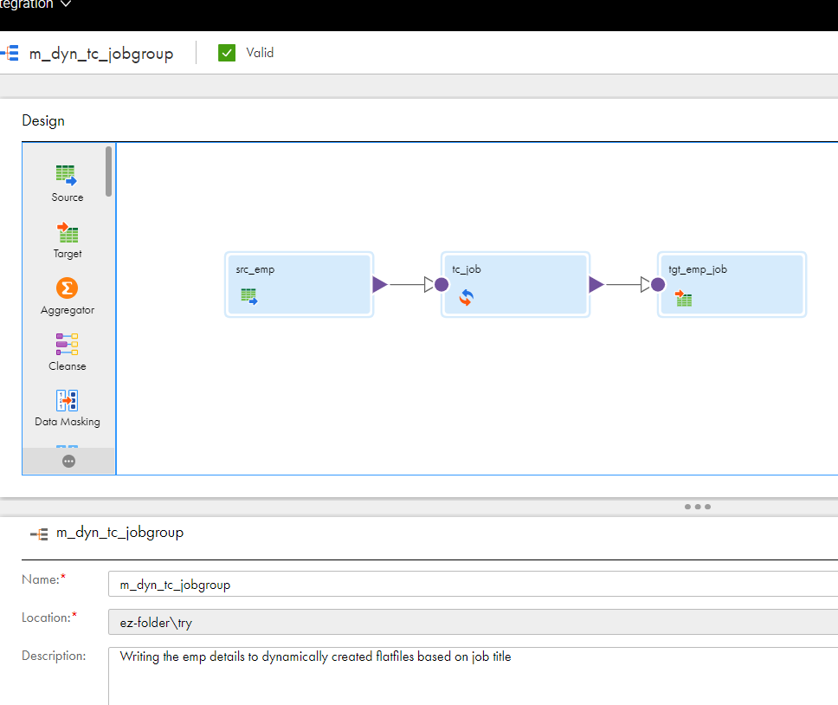

Output files generated:

